**Exercise 7: Implementing Constructor and Setter Injection**

**Scenario:**

The library management application requires both constructor and setter injection for better control over bean initialization.

**STRUCTURE:**

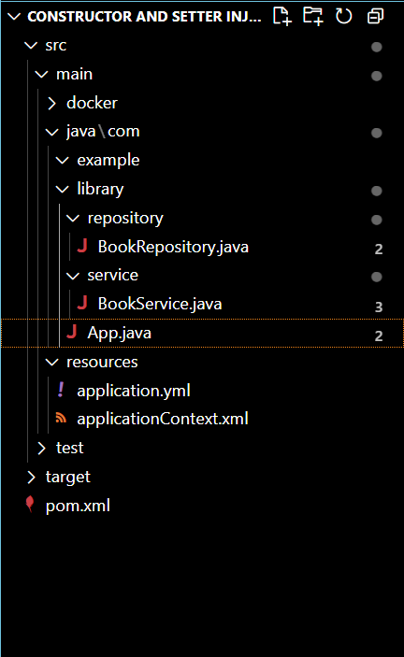

**BookRepository.java**

package com.example.library.repository;

public class BookRepository {

    public void saveBook() {

        System.out.println("BookRepository: Book saved.");

    }

}

**BookService.java**

// BookService.java

package com.example.library.service;

import com.example.library.repository.BookRepository;

public class BookService {

    private String serviceName;

    private BookRepository bookRepository;

    // Constructor Injection

    public BookService(String serviceName) {

        this.serviceName = serviceName;

        System.out.println("Constructor injected: serviceName = " + serviceName);

    }

    // Setter Injection

    public void setBookRepository(BookRepository bookRepository) {

        this.bookRepository = bookRepository;

        System.out.println("Setter injected: bookRepository set");

    }

    public void addBook() {

        System.out.println("BookService [" + serviceName + "] adding book...");

        bookRepository.saveBook();

    }

}

**App.java**

// MainApp.java

package com.example.library;

import org.springframework.context.ApplicationContext;

import org.springframework.context.support.ClassPathXmlApplicationContext;

import com.example.library.service.BookService;

public class App {

    public static void main(String[] args) {

        ApplicationContext context = new ClassPathXmlApplicationContext("applicationContext.xml");

        BookService bookService = context.getBean("bookService", BookService.class);

        bookService.addBook();

    }

}

**applicationContext.xml**

<?xml version="1.0" encoding="UTF-8"?>

<beans xmlns="http://www.springframework.org/schema/beans"

       xmlns:xsi="http://www.w3.org/2001/XMLSchema-instance"

       xsi:schemaLocation="

           http://www.springframework.org/schema/beans

           http://www.springframework.org/schema/beans/spring-beans.xsd">

    <!-- BookRepository bean -->

    <bean id="bookRepository" class="com.example.library.repository.BookRepository" />

    <!-- BookService bean with constructor and setter injection -->

    <bean id="bookService" class="com.example.library.service.BookService">

        <!-- Constructor injection -->

        <constructor-arg value="Library Book Service" />

        <!-- Setter injection -->

        <property name="bookRepository" ref="bookRepository" />

    </bean>

</beans>

**Pom.xml**

<project xmlns="http://maven.apache.org/POM/4.0.0"

         xmlns:xsi="http://www.w3.org/2001/XMLSchema-instance"

         xsi:schemaLocation="http://maven.apache.org/POM/4.0.0

                             http://maven.apache.org/xsd/maven-4.0.0.xsd">

    <modelVersion>4.0.0</modelVersion>

    <groupId>com.example.library</groupId>

    <artifactId>LibraryManagement</artifactId>

    <version>1.0-SNAPSHOT</version>

    <dependencies>

        <!-- Spring Context -->

        <dependency>

            <groupId>org.springframework</groupId>

            <artifactId>spring-context</artifactId>

            <version>5.3.33</version>

        </dependency>

        <!-- Spring AOP -->

        <dependency>

            <groupId>org.springframework</groupId>

            <artifactId>spring-aop</artifactId>

            <version>5.3.33</version>

        </dependency>

        <!-- Spring Web MVC -->

        <dependency>

            <groupId>org.springframework</groupId>

            <artifactId>spring-webmvc</artifactId>

            <version>5.3.33</version>

        </dependency>

        <!-- (Optional) Logging dependency -->

        <dependency>

            <groupId>org.slf4j</groupId>

            <artifactId>slf4j-api</artifactId>

            <version>1.7.36</version>

        </dependency>

        <!-- (Optional) Runtime Logging Binding -->

        <dependency>

            <groupId>org.slf4j</groupId>

            <artifactId>slf4j-simple</artifactId>

            <version>1.7.36</version>

        </dependency>

    </dependencies>

    <build>

        <plugins>

            <!-- Compiler Plugin -->

            <plugin>

                <groupId>org.apache.maven.plugins</groupId>

                <artifactId>maven-compiler-plugin</artifactId>

                <version>3.8.1</version>

                <configuration>

                    <source>1.8</source>

                    <target>1.8</target>

                </configuration>

            </plugin>

            <plugin>

    <groupId>org.codehaus.mojo</groupId>

    <artifactId>exec-maven-plugin</artifactId>

    <version>3.1.0</version>

    <configuration>

        <mainClass>com.example.library.App</mainClass>

    </configuration>

</plugin>

            <!-- Exec Plugin to run Java main class -->

            <plugin>

                <groupId>org.codehaus.mojo</groupId>

                <artifactId>exec-maven-plugin</artifactId>

                <version>3.1.0</version>

                <configuration>

                    <mainClass>com.example.library.App</mainClass>

                </configuration>

            </plugin>

        </plugins>

    </build>

</project>

**OUTPUT:**

